

Submitted

IN PARTIAL FULLDILLMENT OF THE REQUREMENT

FOR THE

ALL INDIA SENIOR SCHOOL CERTIFICATE

EXAMINATION

SESSION:2024-25

PHYSICS INVESTIGATORY PROJECT ON

**STUDY OF EARTH’S MAGNETIC FIELD USING A COMPASS NEEDLE-BAR MAGNET BY PLOTTING MAGNETIC FIELD LINES AND TANGENT GALVANOMETER**

**GUIDED BY:- SUBMITTED BY:-**

**Mr.Tabish zuberi Akshat Sharma**

**CERTIFICATE**



**This is to certify that Akshat Sharma of class XII F,bearing registration number ___________ from International Public School, Bhopal has successfully completed the physics project entitled-**

*STUDY OF EARTH’S MAGNETIC FIELD USING A COMPASS NEEDLE-BAR MAGNET BY PLOTTING MAGNETIC FIELD LINES AND TANGENT GALVANOMETER*

**Under the guidance of Mr. Tabish Zuberi in laboratory of the institution prescribed by CBSE for AISSCE**

**2024-2025.**

**Teacher’s Signature Principal’s Signature**

**Examiner’s Signature Date:**

ACKNOWLEDGEMENT

I wish to express my deep gratitude and sincere thanks to the principal, Mrs.Deepti Singh for her encouragement provided for this project. I extend my hearty thanks to, Mr.Tabish Zuberi, my physics teacher, who guided me to successful completion to this project on the topic **:**

*STUDY OF EARTH’S MAGNETIC FIELD USING A COMPASS NEEDLE-BAR MAGNET BY PLOTTING MAGNETIC FIELD LINES AND TANGENT GALVANOMETER*

Secondly I offer my sincere thanks to my parents and my friends who helped me to carry out this project work successfully and for their support, which I receive from them time to time.

**INDEX**

1. **AIM**
2. **APPARATUS**
3. **PRINCIPLES APPLIED AND THEORY**
4. **PROCEDURE**
5. **OBSERVATION**
6. **RESULT**
7. **PRECAUTIONS**
8. **BIBLOGRAPHY**

*AIM*

*STUDY OF EARTH’S MAGNETIC FIELD USING A COMPASS NEEDLE-BAR MAGNET BY PLOTTING MAGNETIC FIELD LINES AND TANGENT GALVANOMETER.*

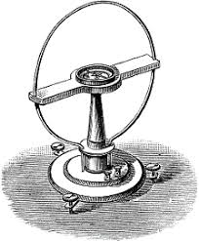

**APPARATUS REQUIRED**

* Tangent galvanometer
* Commutator
* Rheostat
* Battery
* Ammeter
* Key
* Spirit level
* Meter scale
* Thread
* Connecting wires
* Sand paper

HISTORY AND OVERVIEW

* A tangent galvanometer is an early measuring

instrument used for the measurement of electric

current. It works by using a compass needle to compare

a magnetic field generated by the unknown current to

the magnetic field of the Earth. It gets its name from its

operating principle, the tangent law of magnetism,

which states that the tangent of the angle a compass

needle makes is proportional to the ratio of the

strengths of the two perpendicular magnetic fields. It

was first described by Claude Pouillet in 1837, who later

employed this sensitive form of galvanometer to verify

Ohm’s Law.

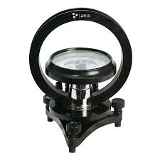

* To use the galvanometer, it is first set up on a level surface and the coil aligned with the magnetic north-south direction. This means that the compass needle at the middle of the coil is parallel with the plane of the coil when it carries no current. The current to be measured is now sent through the coil, and

produces a magnetic field, perpendicular to the plane of the

coil and is directly proportional to the current.

* The magnitude of the magnetic field produced by the coil is B;

the magnitude of the horizontal component the Earth's magnetic field is B'. the compass needle aligns itself along the vector sum of B and B' after rotating through an angle Ø from its original orientation. The vector diagram shows that tan Ø = B/B'. since the magnetic field of the Earth is constant, and B depends directly on the current, the current is thus proportional to the tangent of the angle through which the needle has turned .

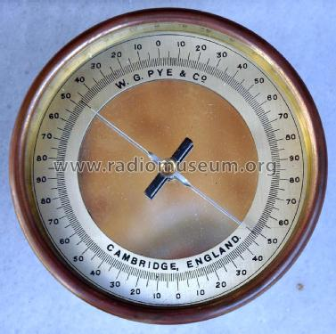

**THEORY**

* Tangent galvanometer is an early measuring instrument

for small electric currents. It consists of a coil of

insulated copper wire wound on a circular non-magnetic

frame. Its working is based on the principle of the

tangent law of magnetism. When a current is passed

through the circular coil, a magnetic field (B) is produced

at the center of the coil in a direction perpendicular to

the plane of the coil. The TG is arranged in such a way

that the horizontal component of earth's magnetic field

(Bh) is in the direction of the plane of the coil. The

magnetic needle is then under the action of two

mutually perpendicular fields. If O is the deflection of the needle, then according to tangent law,

B=Bhtan *θ*........ (1)

* Let I is the current through the coil of radius a with n turns, then the field generated by the current carrying circular coil is,

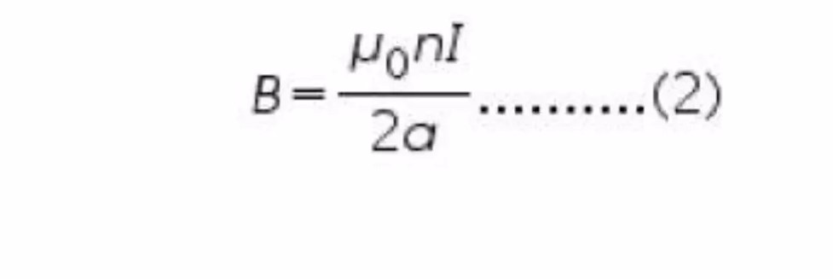

* Equating (1) and (2), we get,

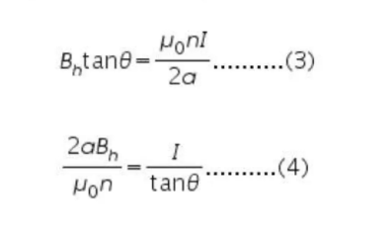

* Using equation (4), the value of Bh can be obtained.
* The left hand side of equation (4) is a constant and is called the reduction factor (K) of the given tangent galvanometer.

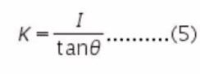

* Now from equation (3) & (5), the horizontal intensity of earth's magnetic field Bh is,

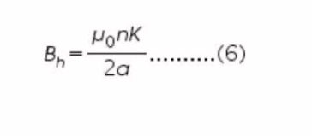

* APPLICATIONS
* T.G can be used to measure the magnitude of the horizontal component of the geomagnetic field.
* The principle can be used to compare the galvanometer constants .

One problem with the tangent galvanometer is that its resolution degrades at both high currents and low currents. The maximum resolution is obtained when the value of 9 is 45°. When the value of 9 is close to o or 90°, a large percentage change in the current will only move the needle a few degrees.

**FACTS**

* The tangent galvanometer is an early measuring instrument for Current.
* The magnetic field produced by a circular coil carrying current I is Proportional to I.
* The S.I unit of magnetic field is Tesla
* The magnitude of horizontal intensity of earth's magnetic field is 3.5x105 T
* For better result while doing tangent galvanometer experiment, the deflection should be in between *30-60* degrees.
* The value of µo is 

**PROCEDURE**

INITIAL SETUP

Connections are made as shown in the figure given below, where K is the key, E the battery, A the ammeter, R the rheostat, C the commutator, and T.G the tangent galvanometer. The commutator can reverse the current through the T.G coil without changing the current in the rest of the circuit. Taking the average of the resulting two readings for deflection averages out, any small error in positioning the TG coil relative to the earth's magnetic field H.

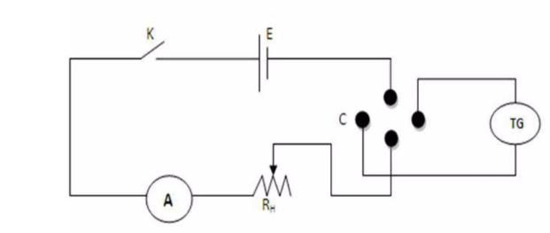

• PROCEDURE FOR PERFORMING THE EXPERIMENT

1. Make the circuit connections in accordance with the circuit diagram.

2. Using spirit level, level the base and the compass needle in compass box of tangent galvanometer by adjusting the levelling screw.

3. Now rotate the coil of the galvanometer about its vertical axis, till the magnetic needle, its image in the plane mirror fixed at the base of the compass box and the coil, i.e. these three lie in the same vertical plane.

4.In this setting, the ends of the aluminium pointer should read zero-zero. If this is not so, rotate the box without disturbing the position of the coil till at least one of the ends of the pointer stands at the zero marks.

5. By closing the key K, the current flow in the galvanometer. Read the both ends of the pointer. Now reverse the direction of current by using the reversing key. When the mean values of both deflections shown by the pointer in the two cases (i.e. before and after reversing the current) differ by more than 10, then turn slightly the vertical coil until the two values agree. This will set the plane of the coil exactly in the magnetic meridian.

6. By adjusting the rheostat, bring the deflection in galvanometer around 45 degrees. The deflection should not be outside the range (30-60 degrees).

7. Record the reading of the ammeter and the deflection of the compass needle in the box shown by two ends of pointer on the scale.

1. Reverse the current in the coil of galvanometer and again record the current and deflection of needle.By changing the value of current, take four or more set of readings and plot the graph between I and tand. The graph will be a straight line.
2. Measure the circumference of the galvanometer coil carefully using a thread and a metre scale.

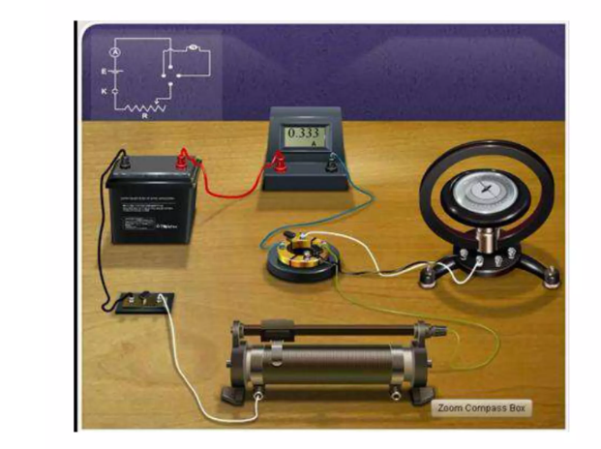

**OBSERVATIONS**

* Number of turns in the coil
* Circumference of the coil = 2πα =
* Radius of the coil =
* Range of ammeter =
* Least count of ammeter =

• Zero error of ammeter =

The Horizontal component of earth's magnetic field (B) can be calculated using the formula,

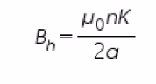

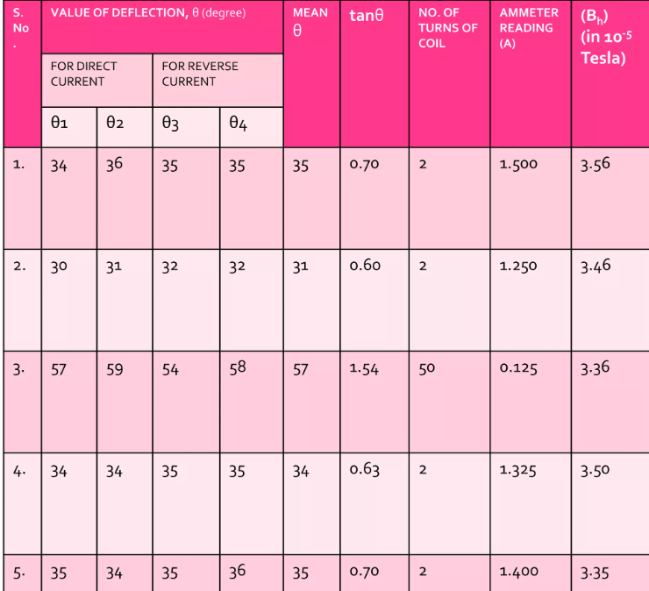

**GRAPH**

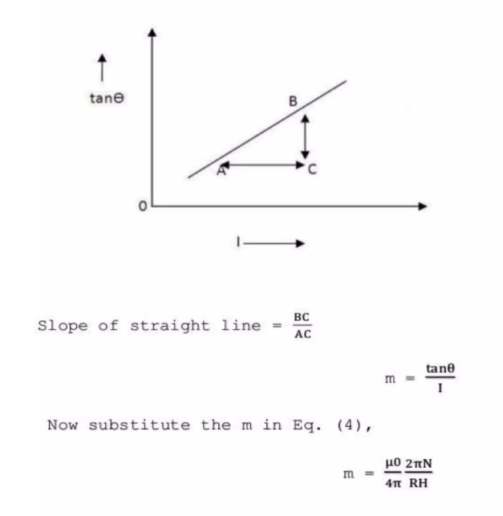

Hence, (Bh) (mean) = 3.45 x 105 T

**RESULT**

Horizontal component of earth’s magnetic field Bh = 3.45 x 105 T

PRECAUTIONS

* The battery should be freshly charged.
* The magnetic needle should swing freely in the horizontal plane.
* The plane of coil must be set in magnetic meridian.
* There should be no parallax in noting down the readings of ammeter and deflection.
* 5 All the readings should be adjusted between 30 and 60 degrees.

**SOURCES OF ERROR**

* There may a magnetic material around apparatus.
* The plane of coil will not be exactly in the magnetic meridian.

BIBLIOGRAPHY

* Google Images
* NCERT Physics Laboratory Manual Class XII
* [www.physicsstackexchange.com/](http://www.physicsstackexchange.com/)
* <https://en.wikipedia.org/wiki/Tangent_galvanometer>
* <https://en.wikipedia.org/wiki/commutator>
* [http://physics.kenyon.edu/EarlyApparatus/Electrical_Measurements/Tangent_Galvanometer/Tangent_Galvanom eter.html](http://physics.kenyon.edu/EarlyApparatus/Electrical_Measurements/Tangent_Galvanometer/Tangent_Galvanom%20eter.html)